**UDP CLIENT**

#include<stdio.h>

#include<string.h>

#include<sys/socket.h>

#include<stdlib.h>

#include<netdb.h>

int main(int argc,char* argv[])

{

struct sockaddr_in server,client;

if(argc!=3)

printf("Input format not correct");

int sockfd=socket(AF_INET,SOCK_DGRAM,0);

if(sockfd==-1)

printf("Error in socket();");

server.sin_family=AF_INET;

server.sin_addr.s_addr=INADDR_ANY;

server.sin_port=htons(atoi(argv[2]));

char buffer[100];

printf("Enter a message to be sent to server");

fgets(buffer,100,stdin);

if(sendto(sockfd,buffer,sizeof(buffer),0,(struct sockaddr*)&server,sizeof(server))<0)

printf("Error in sendto");

return 0;

}

**OUTPUT**

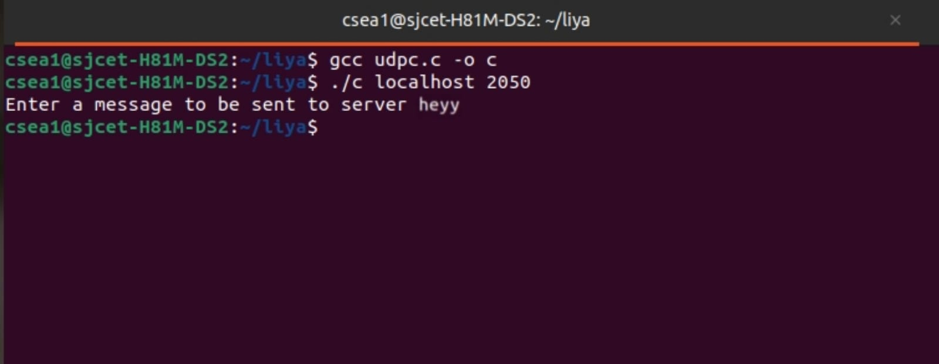

**UDP SERVER**

#include<stdio.h>

#include<string.h>

#include<sys/socket.h>

#include<stdlib.h>

#include<netdb.h>

int main(int argc,char* argv[])

{

struct sockaddr_in server,client;

if(argc!=2)

printf("Input format not correct");

int sockfd=socket(AF_INET,SOCK_DGRAM,0);

if(sockfd==-1)

printf("Error in socket();");

server.sin_family=AF_INET;

server.sin_addr.s_addr=INADDR_ANY;

server.sin_port=htons(atoi(argv[1]));

if(bind(sockfd,(struct sockaddr*)&server,sizeof(server))<0)

printf("Error in blind()! \n");

char buffer[100];

socklen_t server_len=sizeof(server);

printf("server waiting.....");

if(recvfrom(sockfd,buffer,100,0,(struct sockaddr*)&server,&server_len)<0)

printf("Error in recvfrom()!");

printf("Got a datagram:%s",buffer);

return 0;

}

**OUTPUT**

